AI-BASED FINANCIAL IDENTIFICATION BASED ON DEMOGRAPHY AND FINANCIAL FORECASTING
Methodology, Novelty and Key Contributions
Product: FinSight AI
Department of Computer Science and Engineering, TKR College of Engineering and Technology (Autonomous)
Batch C9 (CSE-C) · Academic year [ACADEMIC YEAR]
Table 1: Project team
S.No. | Student name | Roll number
1 | MOHD AHMED | 23K91A05F7
2 | MANNE UPENDER | 23K91A05E6
3 | PADALA RAJESH | 23K91A05H7
4 | MADAGOUNI HARSHAVARDHAN GOUD | 23K91A05D5

Project guide: B SRIKANTH
Chapter and section numbers quoted in the text (for example Section 6.6 or Chapter 8) refer to the full project report, 17.Final Document. Figures and tables in this document are numbered from 1.

1. OVERVIEW OF THE METHODOLOGY
This document describes how the system works from end to end and what is new in it. Part 1 gives the pipeline, the data, the algorithms and the reasons they were chosen; Part 2 sets the work against the base paper and separates what is new from what is standard; Part 3 lists the contributions.

6.1 Overall methodology
The methodology adapts the four-stage explainable machine-learning framework of the base paper [1] (domain-adaptive feature engineering, multi-model training, SHAP interpretation and domain-specific validation) from organisations to individuals, and adds the parts that turn a model into a product: input validation, a forecast, a what-if comparison and a web interface. The work has two halves. An offline half prepares data, trains and evaluates models and writes artifacts; an online half loads those artifacts and answers one request at a time.
1. Acquire the UCI Adult / Census Income files (48,842 individual records) and a monthly economic index series for forecasting.
2. Clean the records: strip whitespace, turn '?' into missing values, coerce numeric columns and drop rows without a target.
3. Engineer twelve interpretable derived features (net capital, capital intensity, log scales, flags, age and hours bands, education tier, region, employment stability, capital position).
4. Split the rows with a stratified 80/20 split (random state 42) and keep the 20% for the final test.
5. Train four classifiers, each inside a scikit-learn Pipeline whose preprocessing is fitted on training data only.
6. Validate with 5-fold stratified cross-validation on the training split, then evaluate on the held-out test split.
7. Select the model with the highest test ROC-AUC and persist all pipelines, metrics, plots, SHAP importance and the forecast.
8. Serve: validate an input record, derive features, predict, map the probability to a profile and risk band, compute local SHAP contributions, write plain-language insights, and optionally compare a what-if scenario.
9. Forecast a 12-month horizon of the economic index with Holt-Winters exponential smoothing and a 95% band.
Table 2: Stages of the base-paper framework and how this project realises them
Base-paper stage | Base paper (hospitals) | This project (individuals)
1. Domain-adaptive feature engineering | 236 line items reduced to 11 ratio, scale and categorical features | 14 raw census fields extended to 26 columns with 12 derived features; 145 columns after one-hot encoding
2. Multi-model training | LR, RF, GB, XGBoost, MLP at default settings | LR, RF, GB, XGBoost; fixed hyperparameters, no search; no neural baseline
3. SHAP interpretation | Global importance and beeswarm; cost ratios dominate | TreeExplainer: global top-15 at training time and live local contributions for every request
4. Domain-specific validation | Hospital-level Group K-Fold, temporal hold-out, counterfactuals, panel regression | Stratified 5-fold CV and 80/20 test split (one row per person); logistic statistics; what-if comparison

6.2 Dataset
The classification data are the Adult (Census Income) extract [32], which originates in the 1994 US census database and was prepared for classification by Kohavi [31]. The project uses both published files, adult.data (32,561 rows) and adult.test (16,281 rows), joined into 48,842 individual records with 15 columns. The positive class, income above 50K per year, covers 23.93% of the rows. Missing values are written as '?' in three columns: workclass (2,799 cells), occupation (2,809) and native-country (857). The records are public and anonymous, and no personal data were collected for this project.
The income label is used as a financial-profile signal. It is not a credit score, a repayment record or a distress indicator, and the report never claims otherwise. This is the main difference from the base paper, whose label is a hospital deficit derived from net income [1], and the reason the comparison in Chapter 8 is given as context only.
Table 3: Facts about the classification dataset
Item | Value
Source | UCI Machine Learning Repository, Adult (Census Income), 1994 US census
Files used | data/raw/adult.data (32,561 rows) and data/raw/adult.test (16,281 rows)
Records after joining | 48,842 rows, 15 columns (14 inputs and the target)
Target | income above 50K (positive) versus 50K or less; test labels carry a trailing '.' that the cleaner removes
Positive-class share | 23.93%
Training / test rows | 39,073 / 9,769 (stratified 80/20, random state 42)
Test class balance | 7,431 at 50K or less, 2,338 above 50K
Form option counts | workclass 8, education 16, marital status 7, occupation 14, relationship 6, race 5, sex 2, country 41
Not available | transactions, balances, credit history, repayment records, time stamps

The Adult data are cross-sectional: every person appears once and there is no date. They therefore cannot be used to forecast the future. A second, separate series is used for the forecasting component: a monthly Household Financial Conditions Index from January 2015 to December 2025 (132 points) generated by build_index_series() with a fixed seed. The index is the sum of a linear trend (100 plus 0.35 per month), a yearly seasonal term of amplitude 4, a six-month downturn of 7 points from March to August 2020 and Gaussian noise with standard deviation 1.6. The series is synthetic, documented as such in data/README.md, and chosen so that the forecasting method can be demonstrated and tested end to end; it carries no information about any real economy, and the abstract's real indicators (inflation, lending rates, GDP) are not integrated.

6.3 Preprocessing and feature engineering
Preprocessing is split in two places on purpose. Operations that need no fitted state (cleaning and derived features) are plain functions in scripts/feature_engineering.py and are applied to all rows before the split. Operations that learn from data (imputation values, category lists, scaling) live in a ColumnTransformer inside each Pipeline and are therefore fitted on training rows only.
clean_frame strips whitespace from text columns, converts '?' to a missing value, coerces age, fnlwgt, education-num, capital-gain, capital-loss and hours-per-week to numbers and removes the trailing '.' from test-file labels. add_derived_features then adds twelve columns, each computable from the raw fields of a new user:
Table 4: Derived features added by add_derived_features()
Feature | Rule | Reason
net-capital | capital-gain minus capital-loss | single investment-position signal
capital-intensity | capital-gain plus capital-loss, at least 0 | overall investment activity
log-capital-gain, log-capital-loss | log(1 + value) | both are highly skewed; helps the linear model
has-capital-gain, has-capital-loss | 1 if the value is above 0, else 0 (as text) | interpretable yes / no indicators
hours-band | up to 29 Part-time; 30-40 Full-time; 41-60 Extended; above 60 Very-long | earning-effort proxy
age-band | up to 25; 26-35; 36-50; 51-65; above 65 | life-stage proxy
education-tier | education-num up to 9 Secondary-or-below; 10-12 Higher-secondary; 13 or more Tertiary | groups 16 levels into 3
region | native-country mapped to North America, Latin America, Europe, Asia, Middle East or Other | regional economic category
employment-stability | government Stable-public; Self-emp-inc Business-owner; Self-emp-not-inc Self-employed; Private with 35 or more hours Stable-private, otherwise Variable-private; Without-pay or Never-worked Not-employed | employment security proxy
capital-position | net-capital below 0 Net-loss; 0 No-capital; 1 to 4,999 Moderate-gain; 5,000 or more High-gain | categorical view of net-capital

The result has 26 columns: 10 numeric (age, fnlwgt, education-num, capital-gain, capital-loss, hours-per-week, net-capital, capital-intensity and the two log columns) and 16 categorical. In the ColumnTransformer, numeric columns receive median imputation (and standard scaling for logistic regression only, because trees are insensitive to scale) and categorical columns receive imputation with the constant "Unknown" followed by one-hot encoding with handle_unknown="ignore", so a category never seen in training cannot crash a request. After encoding the fitted pipeline outputs 145 columns.
def build_preprocessor(scale_numeric: bool) -> ColumnTransformer:
"""Build a leakage-safe ColumnTransformer.

scale_numeric=True for the Logistic Regression pipeline;
tree pipelines use scale_numeric=False.
"""
if scale_numeric:
num_pipe = Pipeline([
("imputer", SimpleImputer(strategy="median")),
("scaler", StandardScaler()),
])
else:
num_pipe = Pipeline([
("imputer", SimpleImputer(strategy="median")),
])
cat_pipe = Pipeline([
("imputer", SimpleImputer(strategy="constant", fill_value="Unknown")),
("onehot", _onehot()),
])
return ColumnTransformer([
("num", num_pipe, NUMERIC_FEATURES),
("cat", cat_pipe, CATEGORICAL_FEATURES),
])

The census sampling weight fnlwgt describes how many people a record represents and has no meaning for a new user. It is kept as a training feature, as in the original data, and left missing at prediction time, where the pipeline imputes the training median; its small SHAP importance (0.101) is reported rather than hidden.

6.4 Algorithm choice and justification
Four classifiers span the range used by the base paper [1]: a linear baseline, a bagging ensemble and two boosting ensembles. Tree ensembles are the natural choice for mixed, tabular data with interactions and skewed numeric columns, and Grinsztajn et al. [23] show that they still outperform deep networks on typical tabular data, which is why no neural network was trained. Explainability, the fifth objective, favours models for which exact attributions exist, which led to SHAP.
Table 5: Methods used and the reason for each
Method | Role | Why chosen | Known limitation
Logistic regression [27] | Interpretable baseline (scaled inputs) | Coefficients readable; performance floor | Cannot represent interactions
Random forest [7] | Bagged-tree comparator | Robust, little tuning, captures non-linearity | Less accurate than boosting here; large model
Gradient boosting [8] | Boosted-tree comparator (scikit-learn) | Sequential error correction; strong on tabular data | Fewer regularisation options than XGBoost
XGBoost [9] | Primary classifier | Regularised boosting; best ROC-AUC in this study; exact TreeExplainer support | Needs care with extrapolation; many hyperparameters (not tuned)
SHAP TreeExplainer [14], [15] | Global and local explanation | Shapley-value attributions, exact and fast for trees; consistent with the base paper | Associational, not causal; correlated features share credit
Holt-Winters smoothing [33], [34] | 12-month forecast | Simple, interpretable trend and seasonality; fits a single monthly series | Assumes the pattern continues; interval is constant in width
Stratified K-fold [26] | Validation | Keeps the 24% positive share in every fold | Not entity-aware (unnecessary: one row per person)

SHAP was preferred to LIME [16] for the reasons the base paper gives: Shapley values satisfy efficiency, symmetry and additivity, TreeExplainer computes them exactly for tree models, and one method supplies both the global ranking and the per-person explanation; comparisons of the two in credit risk [18] and applications to credit decisions [17] point the same way. The base paper's caution also applies here: SHAP attributions describe what the model relies on, not what would happen if a person changed a value.

6.5 Mathematical formulation
Logistic regression models the log-odds of the positive class as a linear function of the encoded and scaled feature vector x:
P(y = 1 | x) = 1 / (1 + exp( -(β0 + βᵀx) )) (1)
Gradient boosting builds an additive model of M shallow trees, each fitted to the gradient of the loss at the current prediction, with learning rate ν. XGBoost adds an explicit regularisation term to the training objective, where T is the number of leaves of a tree and w its leaf weights:
F(x) = Σ_{m=1..M} ν · f_m(x), P(y = 1 | x) = 1 / (1 + exp(-F(x))) (2)
L = Σ_i l(y_i, ŷ_i) + Σ_m Ω(f_m), Ω(f) = γ·T + ½·λ·‖w‖² (3)
In this project λ = 1 (the library default L2 weight written explicitly), the learning rate is 0.05, 400 trees of depth at most 6 are grown, and each tree sees 90% of the rows and 90% of the columns.
Shapley values attribute a prediction to features. For a model f with feature set N of size M, the contribution of feature i is the weighted average of its marginal effect over all feature subsets S:
φ_i = Σ_{S ⊆ N∖{i}} [ |S|! (M − |S| − 1)! / M! ] · [ f(S ∪ {i}) − f(S) ] (4)
f(x) = φ_0 + Σ_{i=1..M} φ_i (local accuracy; for XGBoost the sum is in log-odds) (5)
For the selected model the base value φ_0 is -1.1765 in log-odds, about a 24% probability, which is the share of positive records. The global importance of a feature is the mean of |φ_i| over a sample of 500 training rows; the local explanation of one request uses the five largest positive and five largest negative φ_i.
Profile mapping. The predicted probability p of income above 50K is the financial-strength score. It is converted to a profile and a risk band by two fixed cut-offs chosen for this project:
(profile, risk) = (Established, Low) if p ≥ 0.60; (Developing, Moderate) if 0.35 ≤ p < 0.60; (Emerging, High) otherwise (6)
strength = 100·p, risk score = 100·(1 − p) (7)
Holt-Winters (additive trend and additive seasonality) keeps a level ℓ, a trend b and m = 12 seasonal terms s, updated with smoothing weights α, β and γ that are estimated by optimisation:
ℓ_t = α (y_t − s_{t−m}) + (1 − α)(ℓ_{t−1} + b_{t−1}) (8)
b_t = β (ℓ_t − ℓ_{t−1}) + (1 − β) b_{t−1} (9)
s_t = γ (y_t − ℓ_{t−1} − b_{t−1}) + (1 − γ) s_{t−m} (10)
ŷ_{t+h} = ℓ_t + h·b_t + s_{t+h−m(k+1)}, k = ⌊(h − 1)/m⌋ (11)
The 95% band used by the application is ŷ ± 1.96·σ, where σ is the standard deviation of the in-sample residuals (1.659). It is an approximation with constant width, not a full prediction interval whose width grows with the horizon [36]. The synthetic series itself is y_t = 100 + 0.35t + 4 sin(2π(month_t − 1)/12) + shock_t + ε_t with ε_t ~ N(0, 1.6²).
Evaluation metrics are computed from the confusion matrix (TP, FP, TN, FN) of the positive class, income above 50K:
accuracy = (TP + TN) / (TP + TN + FP + FN); precision = TP / (TP + FP); recall = TP / (TP + FN); F1 = 2·precision·recall / (precision + recall) (12)
ROC-AUC = P( score(positive) > score(negative) ), the area under the TPR-versus-FPR curve (13)
As a check, the selected model's test confusion matrix is TN 7,021, FP 410, FN 780, TP 1,558, so precision is 1,558 / 1,968 = 0.7917, recall is 1,558 / 2,338 = 0.6664 and accuracy is 8,579 / 9,769 = 0.8782, matching the stored report. ROC-AUC [28], [29] equals the probability that a randomly chosen positive record receives a higher score than a randomly chosen negative one.

6.6 Model training and selection
Training is performed by python scripts/train.py. The four candidates are defined in scripts/models.py with fixed hyperparameters and random_state = 42; no grid or random search was run, which follows the base paper's choice of defaults for reproducibility [1] but means the models may be under-tuned.
Table 6: Hyperparameters of the four candidate classifiers
Model | Settings
Logistic Regression | C = 1.0, max_iter 2000; numeric inputs standardised
Random Forest | 300 trees, unlimited depth, min_samples_split 2, all cores
Gradient Boosting | scikit-learn defaults (100 trees, depth 3, learning rate 0.1)
XGBoost | 400 trees, max_depth 6, learning_rate 0.05, subsample 0.9, colsample_bytree 0.9, reg_lambda 1.0, logloss

Each candidate is wrapped as Pipeline([preprocess, model]). The 5-fold stratified cross-validation (shuffled, seed 42) is run on the 39,073 training rows with ROC-AUC as the score; the pipeline is then fitted on all training rows and evaluated once on the 9,769 test rows at the 0.5 threshold. The best model is the one with the highest test ROC-AUC. Selecting on the test split slightly favours the winner and no separate validation set was held out; the cross-validation ranking is identical, which reduces but does not remove that concern. The time taken to train was not recorded.
Table 7: Test-split metrics and cross-validated ROC-AUC of the four models
Model | Accuracy | Precision | Recall | F1 | ROC-AUC | CV ROC-AUC (mean +/- sd)
Logistic Regression | 0.8599 | 0.7568 | 0.6108 | 0.6760 | 0.9140 | 0.9133 +/- 0.0013
Random Forest | 0.8597 | 0.7402 | 0.6373 | 0.6849 | 0.9100 | 0.9079 +/- 0.0016
Gradient Boosting | 0.8697 | 0.7915 | 0.6185 | 0.6944 | 0.9247 | 0.9204 +/- 0.0022
XGBoost | 0.8782 | 0.7917 | 0.6664 | 0.7236 | 0.9319 | 0.9293 +/- 0.0011

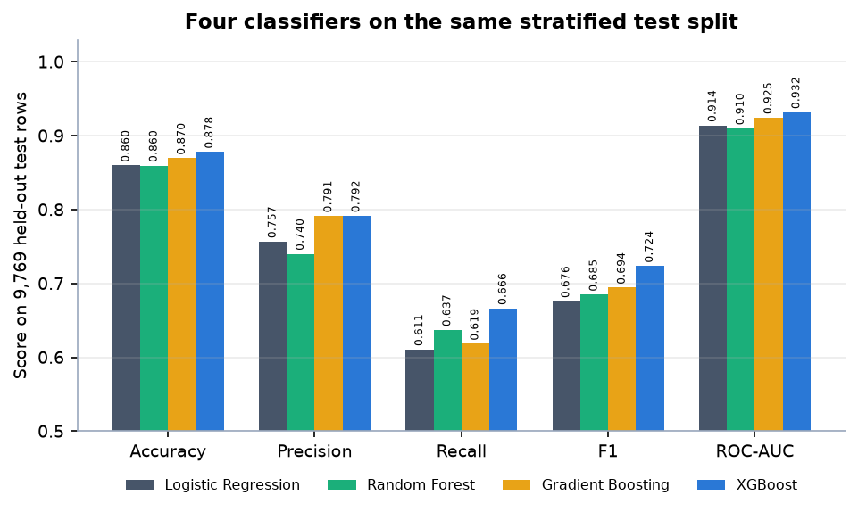
Figure 1: The four classifiers compared on the held-out test split
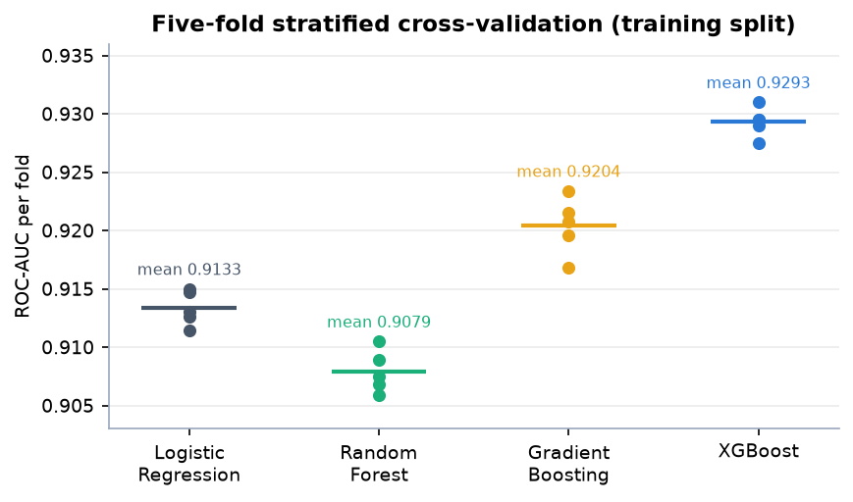
Figure 2: ROC-AUC of every cross-validation fold for each model
XGBoost leads on every metric, with Gradient Boosting a close second (precision 0.7915 against 0.7917); the spread between folds is at most 0.0035 AUC for XGBoost, so the ranking is stable across folds. Chapter 8 gives the confusion matrices and the threshold analysis.

2. NOVELTY AGAINST THE BASE PAPER
The base paper [1] presents a four-stage explainable framework (domain-adaptive feature engineering, multi-model training, SHAP interpretation, domain-specific validation) and instantiates it on 165 Korean hospitals and 825 hospital-year observations to detect financial distress. This project keeps the architecture of that framework and changes the object it is applied to: one person's demographic and financial profile instead of an organisation's disclosed accounts.

What is new in this project
1. A different unit of analysis. The framework is applied to 48,842 individual records with demographic inputs (age, education, occupation, marital status, household role, country) and investment gains and losses. This is the gap named in the literature survey: the surveyed work targets organisations, and demographic context carries much of the signal for individuals.
2. SHAP as a live service. The base paper computes SHAP once, offline, for a research figure. Here a TreeExplainer is built at start-up and local_shap returns the contributions of each request in the response, so every assessment carries its own explanation.
3. Explanations in plain language. Each contribution is turned into a sentence, and one-hot features are read correctly: a value of 0 for occupation = Prof-specialty is reported as the absence of that category, not as an effect of the category itself.
4. A what-if screen. run_whatif predicts twice, for a baseline and for a scenario with changed gains, losses, hours or education, and reports the change in score, profile and risk band, labelled as simulation and not as causation.
5. A forecasting component and a usable interface. A Holt-Winters 12-month forecast with a 95% band, performance views and a React interface sit around the model. The base paper has no application layer.
6. Evaluation of the served system. Besides accuracy and AUC the project reports calibration bins, a threshold sweep, observed income rates per profile band, API latency (68.9 ms median for a prediction) and automated test results.

What is not new
The model families (Logistic Regression, Random Forest, Gradient Boosting, XGBoost [7], [8], [9]), SHAP [14], [15], stratified cross-validation [26] and Holt-Winters smoothing [33], [34] are standard and used as published. The project does not reproduce the base paper's group-wise or temporal validation, its counterfactual subsidy analysis or its panel regression, because one row describes one person and the Adult data have no time dimension. The two studies use different data, targets and protocols, so their scores are not compared as a ranking.
Table 8: Base paper and this project side by side
Aspect | Base paper | This project
Unit | 165 hospitals, 825 hospital-years (2019-2023) | 48,842 individuals (UCI Adult)
Target | Deficit (net income below zero), 41.2% positive | Income above 50K, 23.9% positive, read as a profile signal
Models | LR, RF, GB, XGBoost, MLP | LR, RF, GB, XGBoost
Validation | Hospital-level Group K-Fold, temporal hold-out, stratified K-Fold | Stratified 80/20 split and 5-fold stratified CV (one row per person)
Best AUC | 0.842 (XGBoost, Group K-Fold) | 0.932 (XGBoost, test split)
Explainability | Offline global and local SHAP, cross-method reconciliation | Global SHAP at training time plus live local SHAP per request
Beyond the model | Counterfactual subsidy analysis, panel regression | Web application, what-if, 12-month forecast on a synthetic index

3. KEY CONTRIBUTIONS
The work makes six contributions. Each is stated together with the place where the evidence for it can be inspected.
1. From organisations to individuals. The explainable machine-learning framework of the base paper [1] (feature engineering, multi-model comparison, SHAP, validation) is carried over from hospital panel data to individual demographic and financial profiling on 48,842 census records.
2. An end-to-end system, not only a model. Validated form input, feature engineering, XGBoost prediction, profile and risk band, live SHAP explanation, what-if comparison, forecast and performance views are served through a Flask API and a React interface.
3. Leakage-safe, reproducible evaluation. Imputation, encoding and scaling live inside each Pipeline; four models are compared on one stratified split plus 5-fold CV; every metric is written to JSON and re-derived by a script.
4. Explanations in plain language. Per-assessment SHAP values become sentences, including a correct reading of one-hot features (the absence of a category), and the what-if screen is labelled as simulation, not causation.
5. A forecasting component with honest provenance. A Holt-Winters 12-month forecast with a 95% band is built on a documented synthetic index and its limits are stated wherever it appears.
6. Evaluation beyond a single score. Confusion matrices, a threshold sweep, calibration bins, observed income rates per profile band, API latency and automated test results are reported.
Contribution 1. Evidence: Chapters 4 and 6, the data description in data/README.md and the 12-field form validated by validate_assessment.
Contribution 2. Evidence: the screens of Chapter 8 and Appendix C and the 9 passing tests; every screen is backed by an API route.
Contribution 3. Evidence: build_preprocessor places the imputers, encoder and scaler inside each Pipeline, and artifacts/*.json hold every number quoted in this report.
Contribution 4. Evidence: local_shap and build_insights in app/services/predictor.py and the What shaped your score panel on the result screen.
Contribution 5. Evidence: scripts/forecast.py and data/README.md, which state that the index is synthetic; the forecast screen repeats this in its interpretation text.
Contribution 6. Evidence: Chapter 8 tables and figures: confusion matrices, threshold analysis, calibration bins, profile-band rates, latency and test counts.

